B.M.S. COLLEGE OF ENGINEERING BENGALURU
Autonomous Institute, Affiliated to VTU



Lab Record

Object-Oriented Modeling – 23CS5PCOOM

Submitted in partial fulfillment for the 5th Semester Laboratory

Bachelor of Engineering
in
Computer Science and Engineering

Submitted by:

DISHA D S

1BM23CS094

Department of Computer Science and Engineering
B.M.S. College of Engineering
Bull Temple Road, Basavanagudi, Bangalore 560 019
August 2025-December 2025

B.M.S. COLLEGE OF ENGINEERING
DEPARTMENT OF COMPUTER SCIENCE AND ENGINEERING



CERTIFICATE

This is to certify that the Object-Oriented Modeling(23CS5PCOOM) laboratory has been carried out by DISHA D S (1BM23CS094) during the 5th Semester August 2025-December 2025
.

Signature of the Faculty Incharge:

Prof. Sonika Sharma D

Department of Computer Science and Engineering
B.M.S. College of Engineering, Bangalore

Table of Contents

1 . Hotel Management System 4
- Credit Card Processing 22
- Library Management System 39
- Stock Maintenance System 51
- Passport Automation System 63

1. Hotel Management System
Problem Statement
The current manual process of managing hotel operations—such as room booking, check-in/check-out, payment handling, and staff coordination—is time-consuming and prone to errors. Customers often face issues like unclear room availability and delayed confirmations, while administrators struggle to maintain accurate records and monitor hotel activities efficiently. To overcome these limitations, a Hotel Management System is needed to automate reservations, streamline customer and staff interactions, maintain real-time room availability, and ensure smooth and efficient hotel operations.

Software requirement specification
1. Introduction
1.1 Purpose
The purpose of the Hotel Management System (HMS) is to automate and simplify hotel operations such as room reservation, check-in/check-out, customer management, payment processing, and room status tracking. The system replaces manual operations with an efficient, accurate, and user-friendly software solution for customers, staff, and administrators.
1.2 Scope
The HMS provides functionalities for customers to search rooms, book reservations, and make payments. Hotel staff can manage check-ins, check-outs, verify customer details, and update bookings. Administrators can manage rooms, staff, pricing, and generate reports. The system ensures real-time room availability, secure data handling, and improved operational efficiency.
1.3 Overview
This SRS document describes the overall structure, functionality, constraints, performance expectations, and non-functional requirements of the HMS. It includes general descriptions, functional and interface requirements, system constraints, and preliminary project planning.

2. General Description
The HMS is an interactive software system designed for hotels to manage customer activities and internal hotel operations. It consists of modules such as customer registration, room booking, room management, payment processing, and staff administration. The system supports three major users: Customer, Hotel Staff, and Administrator. It maintains centralized data, ensures real-time updates, and provides secure transactions.

3. Functional Requirements
3.1 Customer Requirements
- FR1: The system shall allow customers to search for available rooms.
- FR2: The system shall allow customers to register and log in.
- FR3: The system shall allow customers to make room reservations.
- FR4: The system shall allow customers to cancel existing reservations.
- FR5: The system shall display booking history and payment details.
3.2 Staff Requirements
- FR6: The system shall allow staff to verify customer identity.
- FR7: The system shall allow staff to perform check-in and check-out operations.
- FR8: The system shall allow staff to update room status and booking details.
3.3 Admin Requirements
- FR9: The system shall allow admin to add, update, and delete room details.
- FR10: The system shall allow admin to manage staff accounts.
- FR11: The system shall generate operational reports (booking, customers, payments).

4. Interface Requirements
4.1 User Interface
- Simple, intuitive GUI with dashboards for Customer, Staff, and Admin.
- Room availability displayed in tabular or card view.
- Login & registration forms with validation feedback.
4.2 Hardware Interface
- Standard desktop/mobile devices with internet access.
- Barcode/ID scanner support for customer verification (optional).
4.3 Software Interface
- Database: SQL/NoSQL database for storing customer, booking, and room data.
- Payment Gateway API for online transactions.
- Email/SMS notification services.

5. Performance Requirements
- The system should respond to user actions within 2–3 seconds.
- Room availability and booking updates should be reflected in real time.
- The system should support at least 200 concurrent users.
- Data retrieval and report generation must complete within 5 seconds.

6. Design Constraints
- The system must comply with data privacy regulations.
- The system must run on commonly used browsers and OS systems.
- The database must ensure ACID properties.
- The payment module must comply with payment security standards (PCI DSS).

7. Non-Functional Requirements
7.1 Security
- User authentication with password encryption.
- Role-based access control for Admin, Staff, and Customer.
7.2 Reliability
- System uptime should be at least 99%.
- Automatic backup every 24 hours.
7.3 Usability
- Easy-to-navigate interface suitable for non-technical staff.
7.4 Maintainability
- Modular design to allow updates without affecting the entire system.
7.5 Scalability
- System should support addition of more rooms, staff, and branches with minimal reconfiguration.

8. Preliminary Schedule and Budget
8.1 Schedule (Example Timeline — 8 Weeks)
- Week 1: Requirement analysis & documentation
- Week 2: UI/UX design
- Week 3–4: Backend development (booking, customer, room modules)
- Week 5: Staff & Admin module development
- Week 6: Integration with payment & notification services
- Week 7: Testing (unit, integration, system)
- Week 8: Deployment & final report preparation
8.2 Budget (Approx. for Academic Project)
- Software tools & libraries: Free (open-source)
- Hosting/server (optional): ₹300–₹500
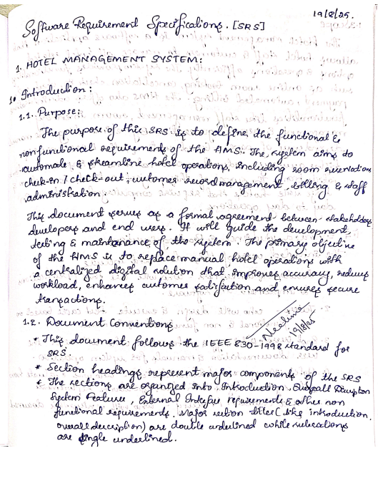
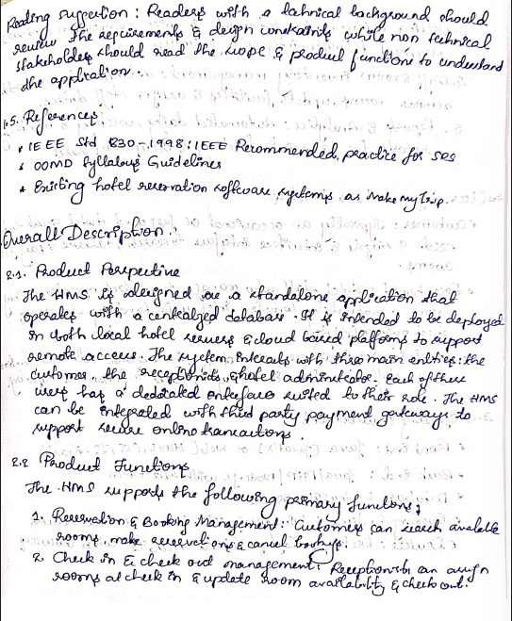
- Miscellaneous (printing, documentation): ₹200
Estimated Total Cost: ₹500–₹700
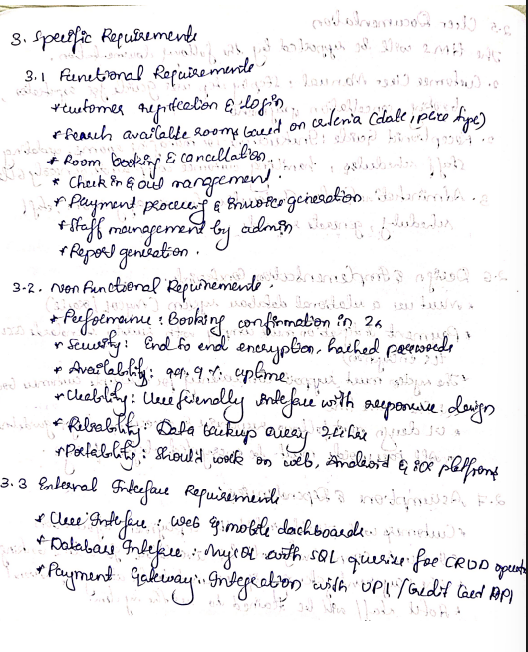
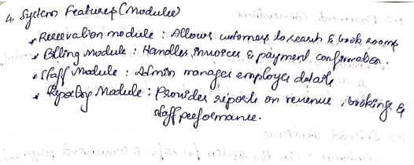
Class diagram:
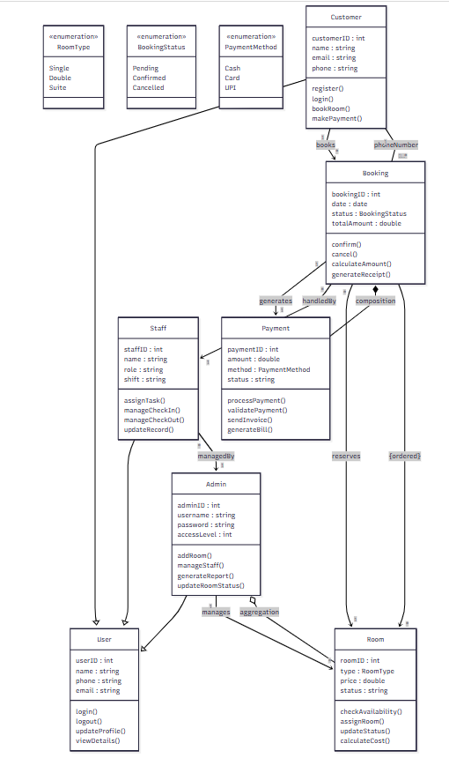

The Hotel Management System class diagram models the major components involved in managing hotel operations such as bookings, customers, rooms, payments, and staff activities. The diagram consists of classes like Customer, Booking, Room, Payment, Staff, Admin, and User, each containing essential attributes and operations required for hotel management. The User class acts as a general parent class for Customer, Staff, and Admin, representing a clear generalization hierarchy.
Customers can make bookings, which are represented by the Booking class, containing attributes such as booking ID, date, total amount, and booking status. A booking is associated with a Payment object through composition, indicating that a payment cannot exist without a booking. Rooms are connected to bookings, with each room having details such as room type, price, and status. The Admin class manages staff and room information through aggregation, showing a whole–part relationship where rooms and staff can exist independently of the admin. The Booking class also interacts with Staff, who manage check-in and check-out activities.
Enumerations such as RoomType, BookingStatus, and PaymentMethod provide controlled sets of values used across classes. Additional UML elements such as multiplicity, ordered associations, and qualified associations help define how objects relate to each other, ensuring clarity and accuracy in the system’s structure. Overall, this class diagram provides a complete, well-structured representation of the static design of the Hotel Management System.

Simple state diagram
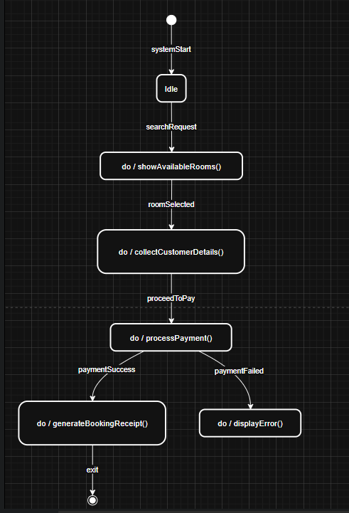

Advanced state diagram
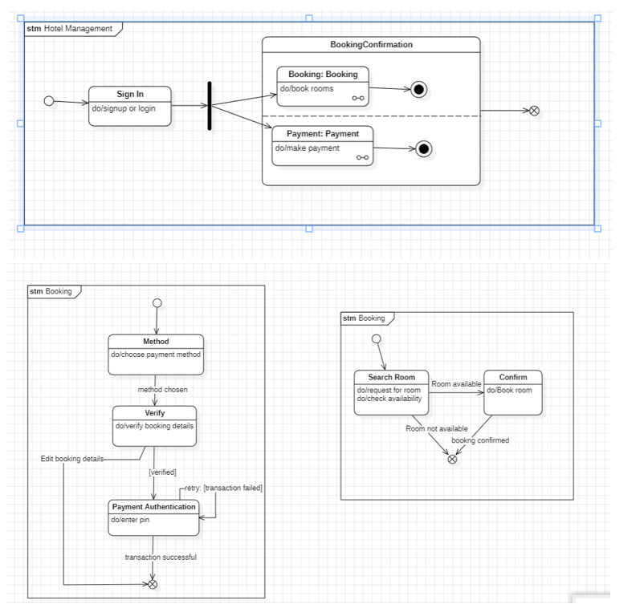
The state diagrams illustrate the behavioral flow of the Hotel Management System, focusing on how bookings and payments are processed. The advanced state diagram shows a composite BookingConfirmation state with two concurrent regions, where booking actions and payment processing occur simultaneously after the user signs in. Each region has its own internal final state, demonstrating parallel completion before the system transitions to the overall final state. The second advanced diagram expands the booking workflow, depicting the steps of selecting a payment method, verifying booking details, and performing payment authentication, including guard conditions for success, failure, and retries. The simple state diagram presents a streamlined view of the booking process, beginning with room search and proceeding to confirmation when a room is available, or terminating if it is not. Together, these diagrams capture both high-level and detailed internal behaviors of the HMS, clearly modeling how user actions drive system responses.

Use case diagram
Simple
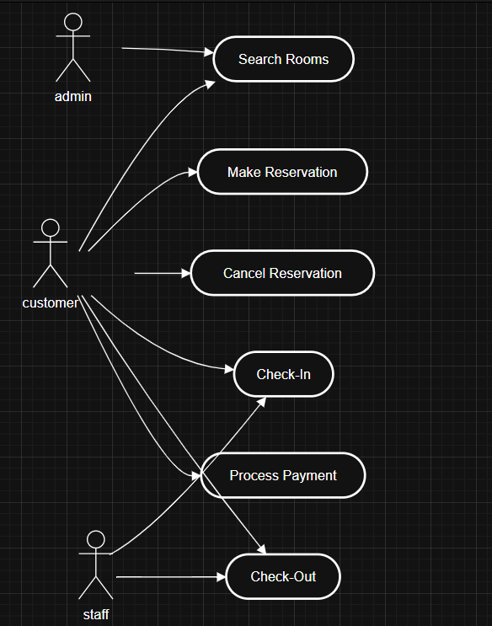
Advanced
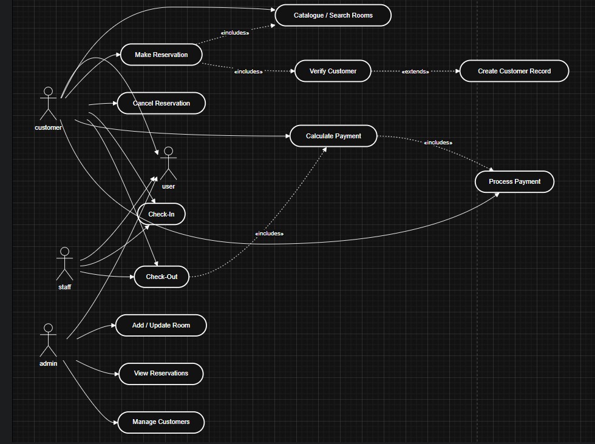
The advanced use case diagram for the Hotel Management System shows how different users interact with the system and how complex system behavior is structured using include, extend, and generalization relationships. Three main actors are involved: Customer, Staff, and Admin, all of which inherit from the more general User actor, representing shared functionalities such as login and profile management.
The Customer actor performs the majority of the use cases, including searching for rooms, making reservations, canceling reservations, checking in, checking out, and making payments. The use case Make Reservation includes Search Rooms, since a customer must first view available rooms before confirming a booking. It also includes Verify Customer, ensuring that customer details are validated before finalizing a reservation. The Verify Customer use case can optionally trigger the Create Customer Record use case through an extend relationship when a new customer’s information is not present in the system.
The Check-Out use case includes Calculate Payment, which itself includes Process Payment, showing a chain of dependent actions required to complete the payment workflow. Staff interact with Check-In and Check-Out, assisting in operational activities. The Admin actor performs system-level actions such as Add/Update Room, View Reservations, and Manage Customers, showing administrative control over hotel operations.
Overall, the advanced use case diagram organizes system behavior into reusable components, demonstrates conditional behaviors through extend relationships, and clearly separates responsibilities across different user roles using generalization. This provides a structured, maintainable view of all interactions within the Hotel Management System.

Sequence Diagram
USE CASE 1: Make Reservation – Scenario
- The customer opens the system to search for rooms.
- The system displays the room search interface.
- The customer enters room preferences (type, date, occupancy).
- The system checks room availability through the Room Manager.
- Available rooms are displayed to the customer.
- The customer selects a room and initiates the reservation.
- The system creates a new booking entry.
- The booking details are stored in the database.
- The system sends confirmation to the customer.
- The customer receives a booking confirmation message

USE CASE 2: Check-Out – Scenario
- The customer approaches the system to check out.
- The system forwards the request to Staff for verification.
- Staff retrieves booking details from the database.
- The system calculates the final amount using the Payment Manager.
- Payment is processed and status is updated.
- Staff confirms successful check-out.
- The system updates room status to “Available.”
- The customer receives final check-out confirmation.

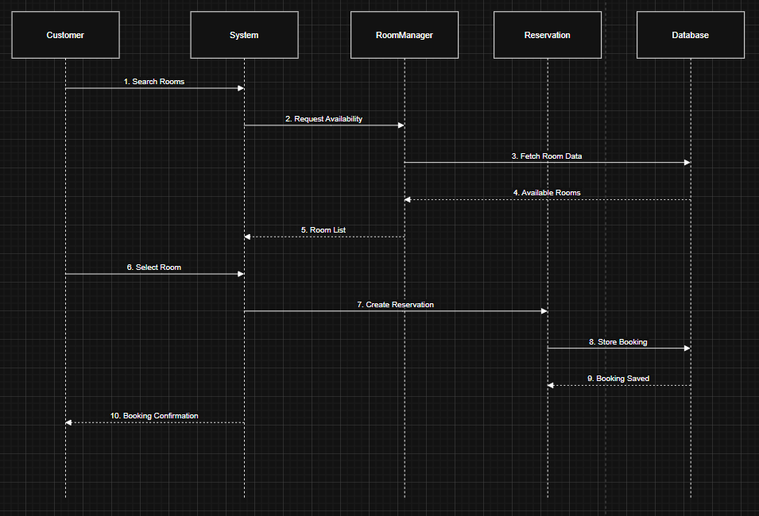
The simple sequence diagram models the basic room reservation process. The customer interacts with the system to search and select a room. The system communicates with the Room Manager and Database to retrieve availability. After the customer selects a room, the system initiates a reservation object, stores it in the database, and returns a booking confirmation. This diagram focuses on a straightforward interaction flow without advanced concepts like transient objects, activation bars, or concurrent processes.

ADVANCED SEQUENCE DIAGRAM
Use case 1
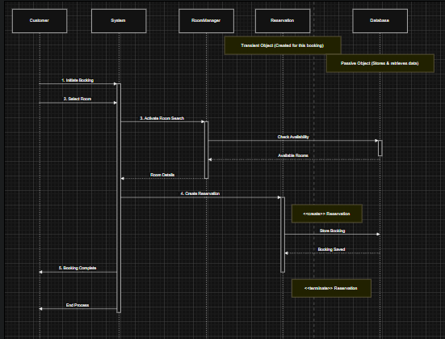
The Make Reservation use case describes how a customer books a room through the Hotel Management System. The process begins when the customer initiates a booking and selects the desired room. The system activates the room search function, checks availability through the Room Manager, and retrieves updated room details from the database. Once availability is confirmed, the system creates a new reservation (a transient object), stores the booking information in the database, and sends a confirmation back to the customer. This use case ensures that room selection, availability verification, reservation creation, and confirmation happen in a smooth and structured flow.

Use case 2
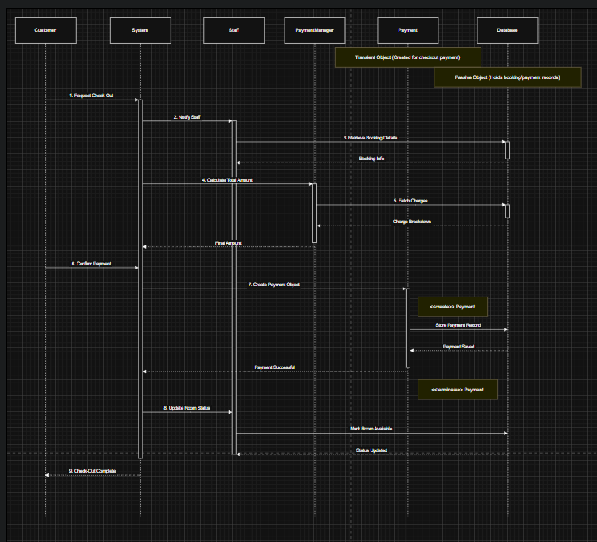
The advanced sequence diagram for the Check-Out use case illustrates how the system handles the completion of a customer’s stay through coordinated interactions among system components. The process begins when the customer requests check-out, triggering the system to notify the staff. The staff retrieves the customer’s booking information from the passive database, which only responds when queried. The system then interacts with the Payment Manager to calculate the final bill, fetching charge details from the database. After the customer confirms payment, a transient Payment object is created solely for the transaction. This object stores the payment record in the database and is then terminated once the payment is processed. Finally, the system instructs staff to update the room status to “Available,” and the customer receives the check-out confirmation. This diagram highlights creation and termination of transient objects, use of passive components, and the detailed coordination required to complete the check-out workflow.
Simple activity diagram
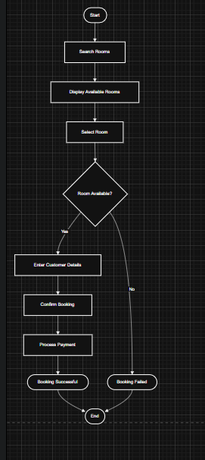
The simple activity diagram represents the basic workflow for booking a room in the Hotel Management System. The process begins with searching for available rooms, displaying options, and allowing the customer to select a room. A decision is made on whether the room is available. If available, the customer enters details, confirms the booking, and completes the payment, ending with a successful booking. If the room is not available, the process terminates with a failed booking. This diagram captures the essential flow without involving different swimlanes or actors.

Advanced activity diagram
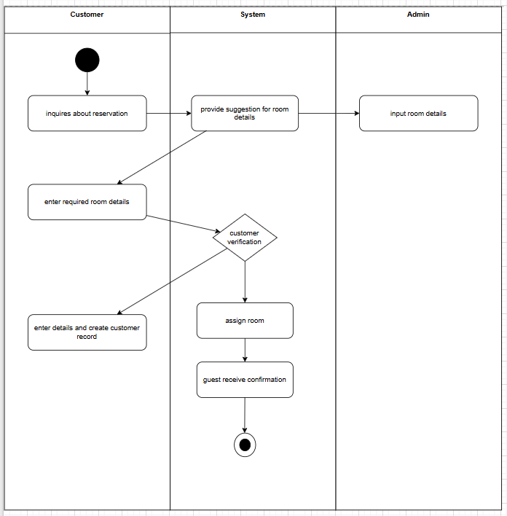
The advanced activity diagram illustrates the room reservation workflow across three responsible entities: Customer, System, and Admin, each represented in separate swimlanes. The process begins in the Customer lane with the user inquiring about a reservation. The System responds by providing room suggestions, while the Admin can input room-related details when required. The customer then enters the required room information, which is sent to the System for customer verification, functioning as the decision point. If the customer is verified, the System proceeds to assign a room and send the confirmation back to the customer. If verification fails, the activity flows toward the customer creating a new record. Finally, the customer receives confirmation, and the process ends at the final node. This diagram clearly distributes responsibilities across actors and captures decision-making and workflow progression, fulfilling the requirements for an advanced activity diagram with swimlanes.

2. Credit Card Processing
Problem statement
The Credit Card Processing System aims to securely handle electronic credit card transactions between customers, merchants, payment gateways, and banking networks. The system must validate card details, authenticate users, check card balance or credit limits, authorize transactions, and process payments in real-time. It should also manage failure cases such as declined transactions, expired cards, incorrect PIN, and network issues. The goal is to provide a fast, reliable, and secure platform that ensures accurate transaction processing while protecting sensitive customer information.

Software Requirements Specification (SRS)
1. Introduction
1.1 Purpose
The purpose of the Credit Card Processing System (CCP) is to provide a secure and efficient platform for validating credit card information, authorizing payments, processing transactions, and generating confirmation responses between customers, merchants, and banks.
1.2 Scope
The system handles end-to-end credit card transactions including card detail submission, validation, balance checking, authorization, payment processing, declined transaction handling, and confirmation delivery. It interfaces with merchants, payment gateways, and bank networks while ensuring high security and compliance.
1.3 Overview
This document defines the functional and non-functional requirements, system interactions, constraints, and performance expectations for the Credit Card Processing System. It outlines how the system validates, processes, and stores transaction records securely.

2. General Description
- The system receives credit card details from the customer or merchant interface.
- The Payment Gateway validates the card format and information.
- The system communicates with the issuing bank to check balance/credit and authorize the transaction.
- Upon approval, the system processes the payment and sends confirmation.
- If any validation or authorization fails, the system returns a decline response.
- The system logs all transactions for auditing.
- Must integrate with existing merchant and banking systems.

3. Functional Requirements
FR1 – Card Detail Submission
- User/merchant submits card number, expiry date, CVV, and amount.
FR2 – Validate Card Information
- System verifies card format, card type, and expiration.
FR3 – Check Balance / Credit Limit
- System communicates with the issuing bank to confirm sufficient funds.
FR4 – Authorize Transaction
- System requests authorization token from the bank.
FR5 – Process Payment
- System transfers funds and records transaction.
FR6 – Handle Declined Transactions
- System returns appropriate decline codes (insufficient funds, invalid card, etc.).
FR7 – Generate Confirmation
- System sends success/decline message to merchant.
FR8 – Log Transaction
- All requests and responses must be logged for auditing.

4. Interface Requirements
4.1 User Interface
- Merchant input form for card details
- Customer payment UI for online transactions
- Status messages: “Approved”, “Declined”, “Processing…”
4.2 Hardware Interface
- POS machine/card reader (optional)
- Merchant terminals
- Server infrastructure
4.3 Software Interface
- Merchant API (REST)
- Bank API
- Payment gateway processing module
4.4 Communication Interface
- HTTPS secure communication
- ISO payment message formats

5. Performance Requirements
- Approval or decline must be returned within 2–5 seconds.
- Must handle high transaction volume with minimal delay.
- System uptime should be 99.9%.
- Low-latency communication with banks.

6. Design Constraints
- Must comply with PCI DSS security standards.
- Must use encrypted storage for sensitive data.
- Must not store CVV after processing.
- Must support bank-specific formatting and protocols.

7. Non-Functional Requirements
Security
- End-to-end encryption (HTTPS/TLS)
- Token-based authentication
- Fraud detection through validation rules
Reliability
- Fault-tolerant architecture
- Backup and recovery mechanisms
Usability
- Simple, intuitive interfaces
- Clear approval/decline messages
Scalability
- Should support growing number of merchants and transactions
Maintainability
- Modular architecture
- Easy integration with future banking APIs

8. Preliminary Schedule and Budget
Schedule (Example Timeline)
Phase | Duration
Requirement Analysis | 1 week
System Design | 2 weeks
Development | 3 weeks
Integration with Bank APIs | 2 weeks
Testing | 2 weeks
Deployment | 1 week
Budget Estimate
- Development & Engineering: 50,000
- API Integration & Licensing: 20,000
- Security & Compliance: 30,000
- Testing and QA: 10,000
- Total Estimated Budget: ≈ 1,10,000
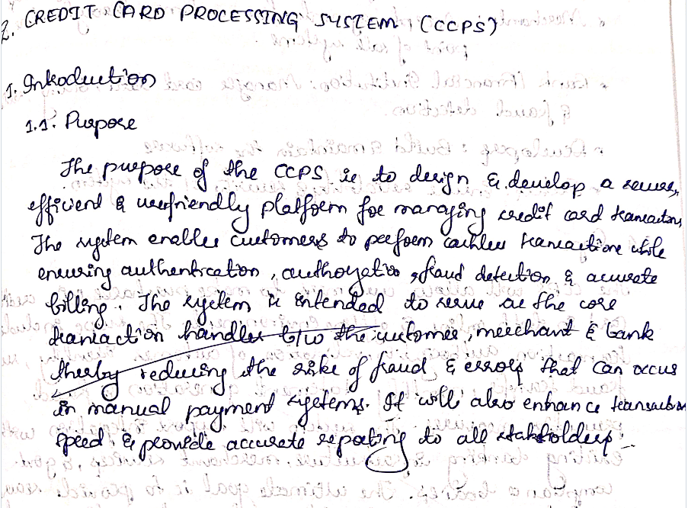
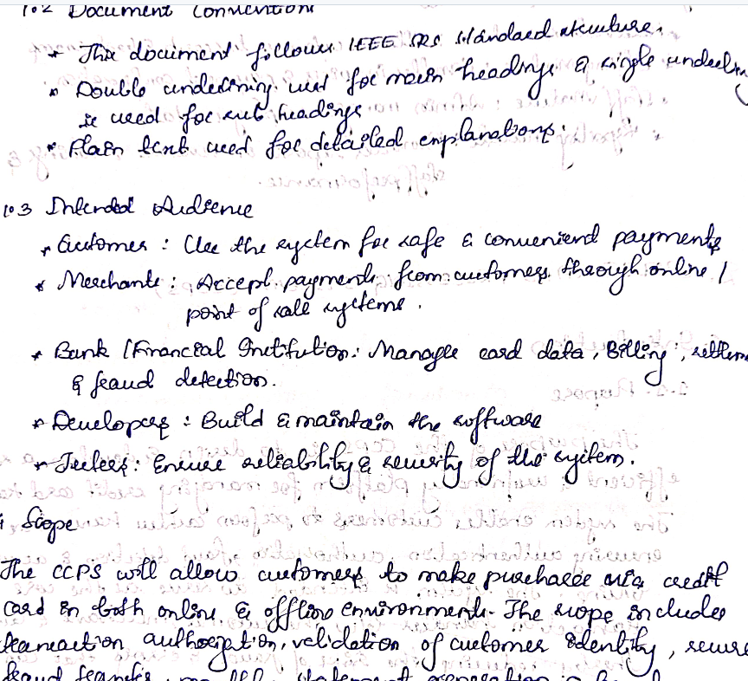

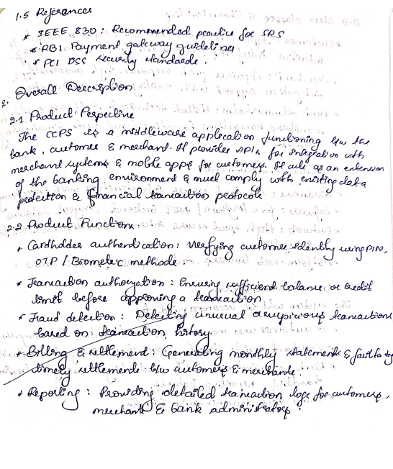
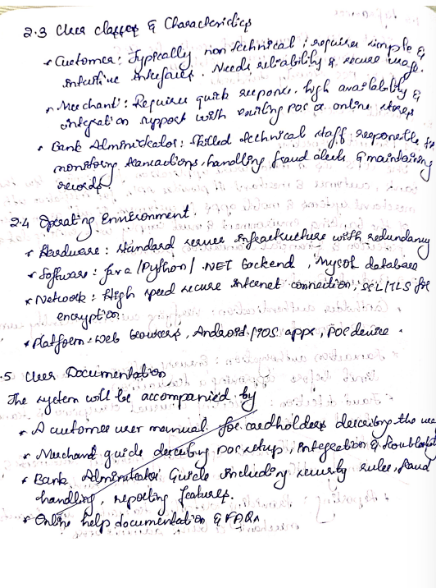

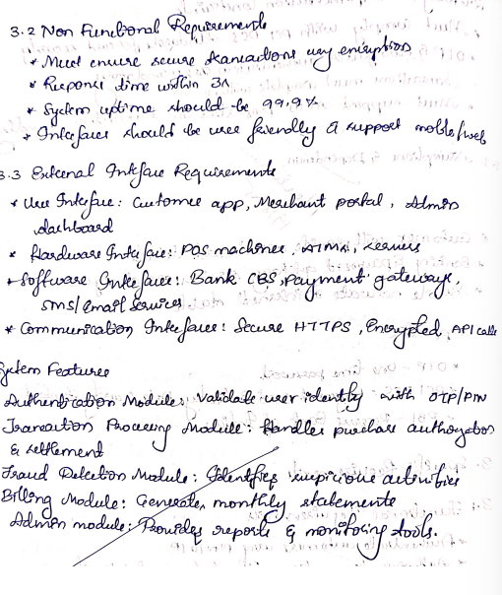

Class diagram

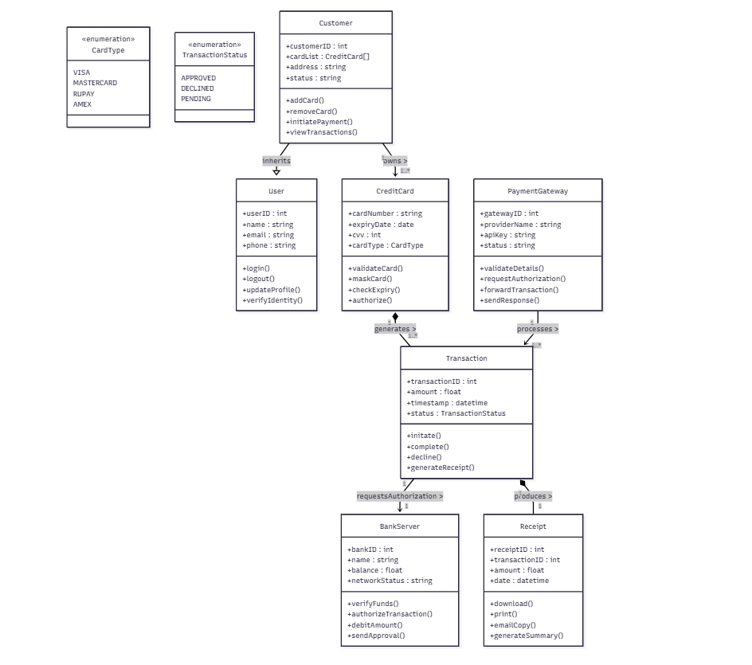
The class diagram models the structure and relationships of the Credit Card Processing System. At the top level, User is the base class containing common attributes such as userID, name, email, and phone, along with basic operations like login(), logout(), and verifyIdentity(). The Customer class inherits from User and adds customer-specific details including cardList, address, and status. It also provides operations for managing cards and initiating payment transactions.
Each Customer can own multiple CreditCard objects, forming a one-to-many association. The CreditCard class stores card-specific attributes such as cardNumber, expiryDate, CVV, and cardType (defined using the CardType enumeration). CreditCard is responsible for validating card information and authorizing use.
A Transaction object is created whenever a payment is initiated. This class is in composition with CreditCard, meaning that transactions cannot exist independently of a card. Each transaction contains details like amount, timestamp, and status (defined using the TransactionStatus enumeration). It includes operations for initiating, completing, declining, and generating receipts.
The PaymentGateway interacts with transactions to validate details, request authorization, and send responses. The association indicates that the gateway processes multiple transactions.
The BankServer performs backend operations such as verifying funds, authorizing transactions, debiting amounts, and sending approval responses. It is associated with Transaction via the requestsAuthorization association.
Finally, each Transaction produces a Receipt, modeled through a composition relationship (transaction cannot exist without its receipt). The Receipt class includes attributes like receiptID, transactionID, date, and amount, with operations to download, print, or email the receipt.
Overall, the diagram effectively demonstrates inheritance, composition, enumerations, multiplicity, and named associations, providing a complete structural view of the Credit Card Processing System.

Simple state diagram
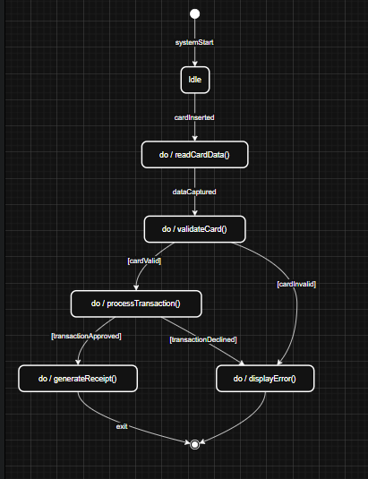
The simple state diagram for the Credit Card Processing System models the basic flow of a credit card transaction. The system starts in the Idle state and transitions to CardInput when the card is inserted. The system reads the card data and moves to Validating, where the card information is checked. If the card is valid, the system enters Processing to execute the transaction; otherwise, it moves to ErrorState. After processing, the transaction either succeeds—leading to the Success state where a receipt is generated—or fails, transitioning to ErrorState. The diagram uses clear do-activities and guard conditions to represent internal actions and decision outcomes.

Advanced state diagram
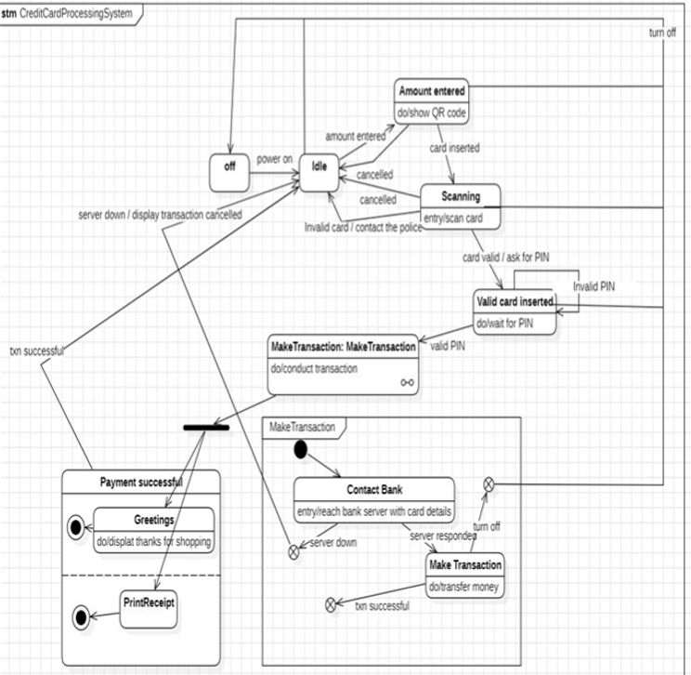

The advanced state diagram models the complete life cycle of a credit card payment transaction, including nested states, do-activities, guard conditions, and exceptional events.
The system starts in the Off state and transitions to Idle when powered on. In the Idle state, a user can enter the transaction amount, leading to the Amount Entered state, where the system performs the activity do/show QR code. When a card is inserted, the system moves to Scanning, which performs do/scan card. Depending on card validity, the system either transitions to Valid Card Inserted or to an error path such as "Invalid card / contact police".
In the Valid Card Inserted state, the system waits for the user to enter a valid PIN. If the PIN is incorrect, it loops back, but if correct, it transitions into the MakeTransaction composite state. Inside this substate, the system contacts the bank server through Contact Bank, performing do/reach bank server with card details. Here, multiple exceptional transitions exist, such as server down or turn off, which terminate the process.
Once the bank server approves the request, the system enters the Make Transaction internal substate to do/transfer money. Successful completion returns the flow to the outer state machine as a "transaction successful" event.
On success, the system transitions to the Payment Successful composite state. This contains two substates: Greetings, which performs do/display thanks for shopping, followed by PrintReceipt, which performs do/print receipt. After printing, the system terminates, returning to the final state.

Use case diagram
Simple
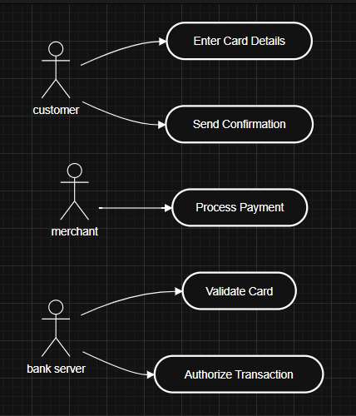

Advanced
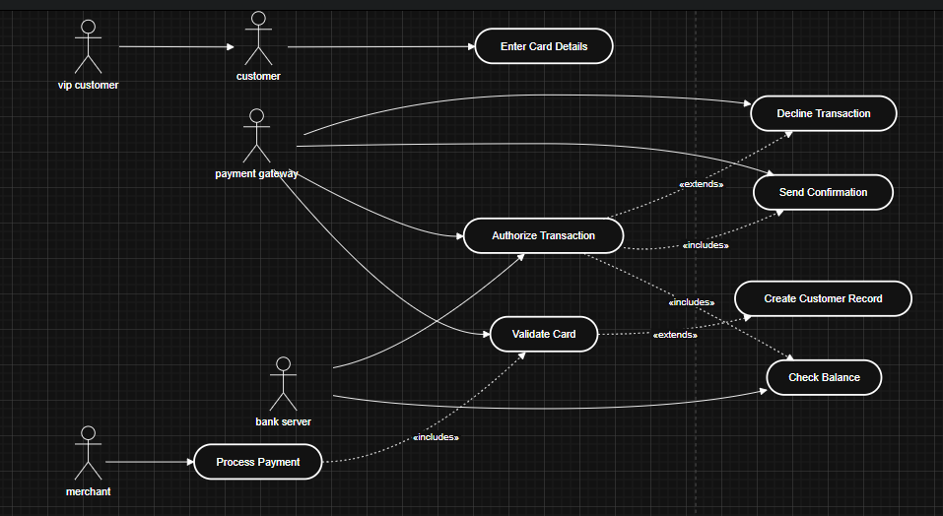
The advanced use case diagram models all major interactions in the Credit Card Processing System. Actors include Customer, Merchant, Payment Gateway, and Bank Server. Core use cases such as entering card details, validating the card, checking balance, authorizing the transaction, processing payment, and sending confirmation are shown. The diagram also incorporates include relationships for mandatory subflows (e.g., authorization requires validation and balance checking) and extend relationships for optional or conditional scenarios such as transaction decline. VIP Customer generalizes Customer to represent special user categories. Overall, the model captures both the normal and exceptional behaviors of the credit card payment workflow.

Sequence diagrams
Use case 1: Enter Card Details & Validate Card
• Customer enters card details into the system.
• System forwards card details to the Payment Gateway.
• Payment Gateway sends the details to the Bank Server.
• Bank Server validates the card.
• Validation result is returned to the Payment Gateway.
• System displays the validation result to the customer.

USE CASE 2: Process Payment
• Customer clicks "Proceed to Pay".
• System sends payment initiation request to Payment Gateway.
• Payment Gateway requests authorization from Bank Server.
• Bank Server approves transaction and returns authorization.
• Payment Gateway confirms payment to the System.
• System notifies customer of successful payment.
• Receipt is generated and stored.

Simple sequence diagram- use case 1
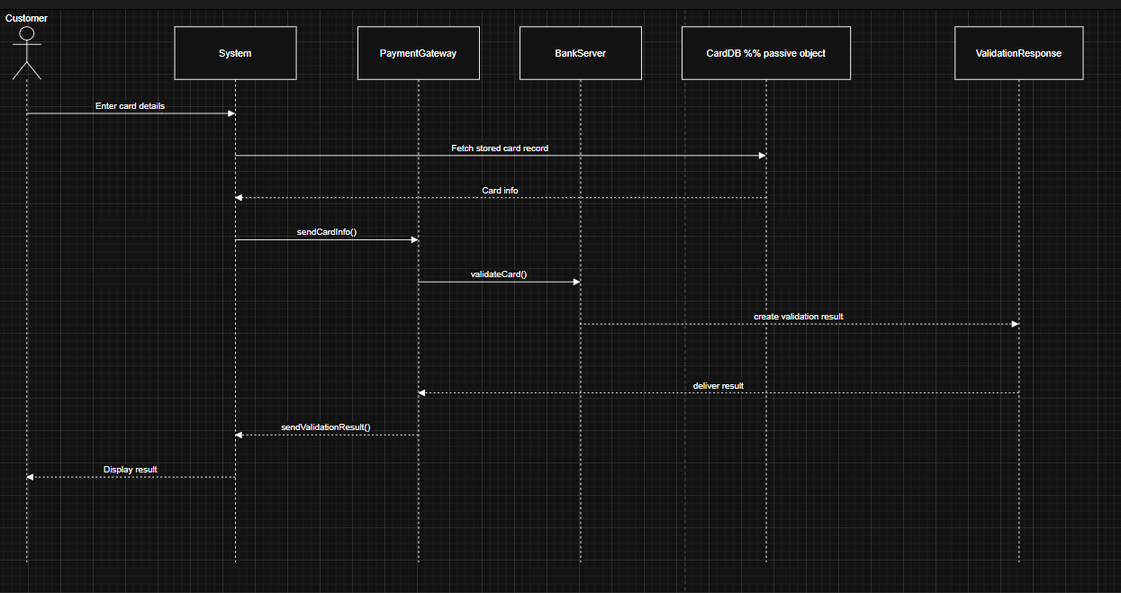

Advanced sequence diagram – use case 2
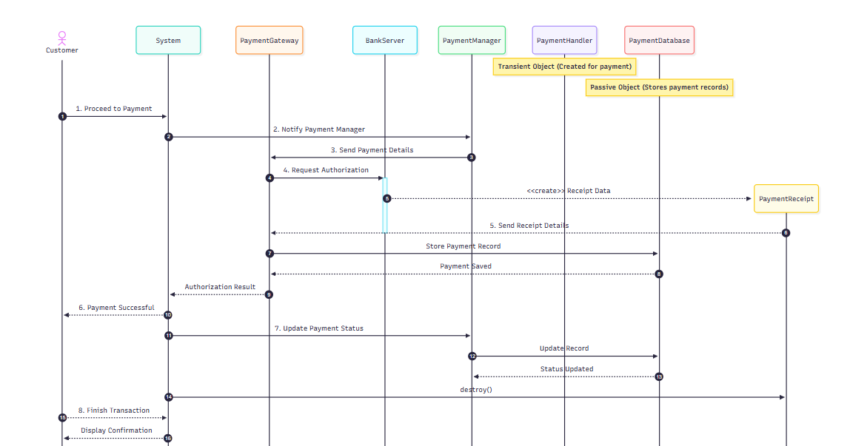
The advanced sequence diagram for the Credit Card Processing System shows the complete internal workflow during payment processing. After the customer initiates payment, the system notifies the Payment Manager, which forwards the transaction to the Payment Gateway. The gateway sends an authorization request to the bank server. The bank creates a transient PaymentReceipt object containing authorization details, which is returned to the gateway and stored in the passive PaymentDatabase. The system then communicates the success back to the customer. Finally, the transient receipt object is terminated. This diagram uses activation flows, transient/passive objects, and object lifecycle management to match advanced UML sequence diagram requirements.

Activity diagram
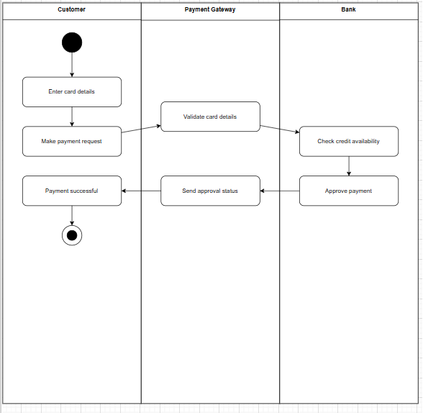
- The Customer starts the process by entering their card details and submitting a payment request.
- The Payment Gateway receives this request and performs a validation check on the card details to ensure the information is correct and the card is usable.
- After validation, the gateway forwards the request to the Bank, where the system checks the credit availability and verifies whether the customer has sufficient funds.
- If everything is correct, the Bank approves the payment and sends the approval status back to the Payment Gateway.
- The Payment Gateway communicates the success message to the Customer.
- Finally, the Customer sees the “Payment Successful” status and the process ends.
Overall, this diagram demonstrates a simple, linear flow of the payment process with no alternate failure paths, focusing only on the successful execution path.

3. LIBRARY MANAGEMENT SYSTEM
Problem Statement
The Library Management System (LMS) helps automate the operations of a library by managing books, members, borrowing, returning, fines, and administration. It allows members to search and borrow books, while librarians manage inventory, issue books, maintain records, and track overdue fines. The system ensures accuracy, reduces manual workload, and improves overall library efficiency.

SRS
1. Introduction
1.1 Purpose
The purpose of this SRS is to define the requirements for a Library Management System that manages books, members, borrowing/returning, librarian operations, and fine calculation.
1.2 Scope
The LMS provides functionalities such as book catalog management, membership registration, book issue/return, fine calculation, and report generation. It involves Members, Librarians, and the Library System backend.
1.3 Overview
This document describes the system features, functional/non-functional requirements, interfaces, constraints, and initial design models.

2. General Description
The LMS is used to manage library transactions efficiently. Members can search, borrow, and return books. Librarians manage book inventory and member records. The system tracks due dates, calculates penalties, and maintains borrowing history.

3. Functional Requirements
FR1: Member Registration
- LMS must allow new users to register as members.
FR2: Book Search
- System must allow users to search books by title, author, or category.
FR3: Book Issue
- Members can borrow available books; the system sets due dates.
FR4: Book Return
- System must update availability and calculate fines (if overdue).
FR5: Book Inventory Management
- Librarians can add/update/remove books.
FR6: Fine Calculation
- LMS should calculate overdue fines automatically.
FR7: Report Generation
- Generate reports for issued books, overdue books, and member history.

4. Interface Requirements
- User Interface: Search screen, issue/return screen, admin dashboard.
- Hardware Interfaces: Barcode scanner support (optional).
- API Interfaces: Database for storage of records.

5. Performance Requirements
- Search results must appear within 2 seconds.
- System must handle 5,000+ books and 1,000 members smoothly.

6. Design Constraints
- Must maintain data consistency during book issue/return.
- Must ensure only librarians can modify inventory.
- System should run on standard Windows/Linux machines.

7. Non-Functional Requirements
- Security: Different permissions for members and librarians.
- Reliability: Safe rollback if book issue/return fails.
- Usability: Simple, menu-driven interface.
- Maintainability: Modular class structure.

8. Preliminary Schedule & Budget
- Duration: 6–8 weeks
- Budget: ₹80,000 – ₹1,00,000
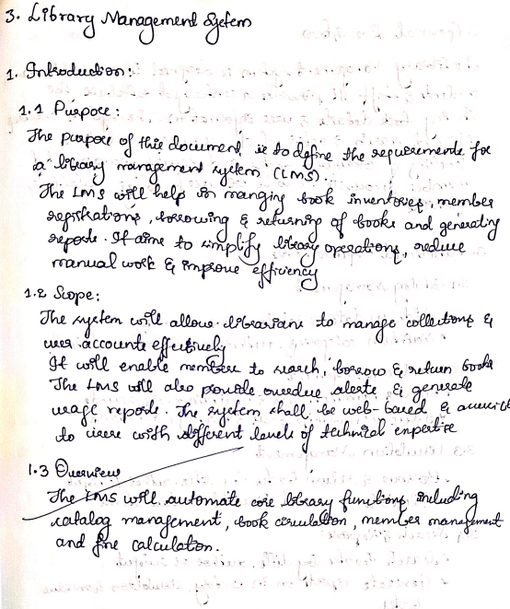
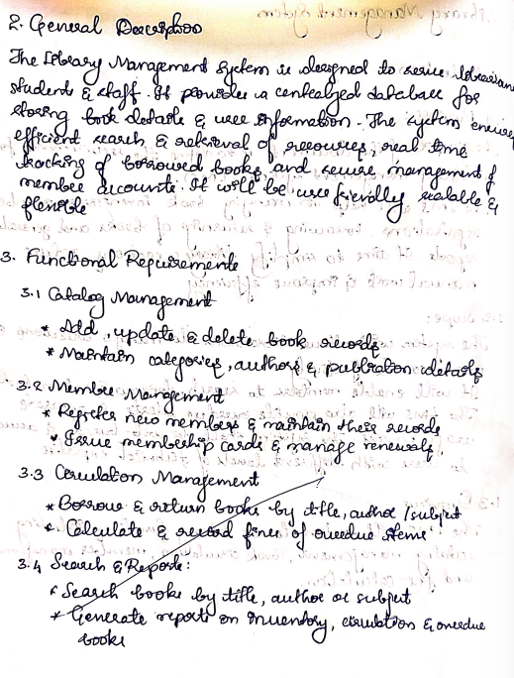
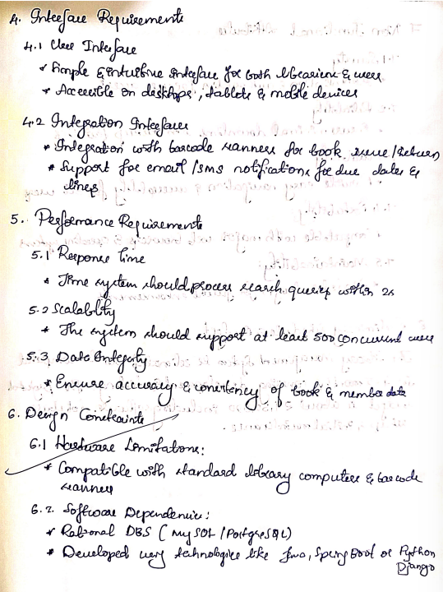
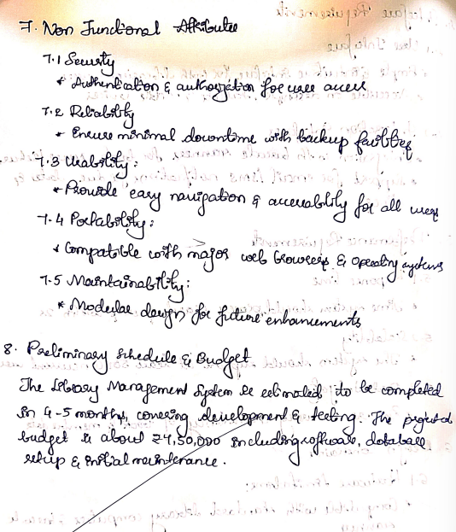

CLASS DIAGRAM
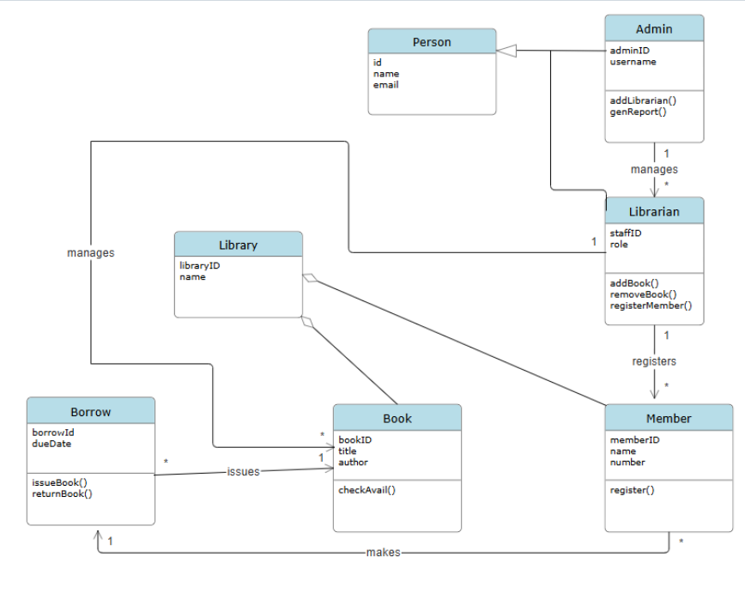
The class diagram models the essential structure and relationships within a Library Management System, involving different actors, resources, and operations that support library administration and book borrowing.
1. Inheritance (Generalization)
The diagram begins with a general class Person, containing common attributes such as id, name, and email.
Both Admin and Librarian inherit from Person, meaning they share these basic properties while also defining additional responsibilities unique to their roles.
2. Admin Class
The Admin manages the overall library system.
It has attributes like adminID and username, and operations such as:
- addLibrarian()
- genReport()
An Admin manages multiple Librarians, represented by a 1 to many association.
3. Librarian Class
The Librarian performs operational tasks involving library resources.
It includes attributes like staffID and role, and operations:
- addBook()
- removeBook()
- registerMember()
A Librarian registers multiple Members, shown via a 1 to many relationship.
4. Member Class
A Member represents individuals using library services.
Attributes include memberID, name, and number.
A Member performs the operation:
- register()
A Member can make multiple Borrow transactions, modeled as a 1-to-many association.
5. Library Class
The Library contains basic information (libraryID, name) and is responsible for managing library resources.
The Library is linked to both Book and Borrow classes, indicating that it:
- has many books
- handles borrow transactions
6. Book Class
The Book class defines library books with attributes such as:
- bookID, title, author
and an operation:
- checkAvail()
A Library maintains multiple Books, indicating aggregation or association.
7. Borrow Class
This class models the borrowing of books, with attributes such as:
- borrowID
- dueDate
Operations include:
- issueBook()
- returnBook()
A Borrow record is associated with:
- One Member (who borrows)
- One Book (which is borrowed)
- The Library (where the transaction occurs)
This forms a meaningful transaction link connecting Member → Book → Borrow.
8. Associations
- Library manages Books and Borrow records.
- Admin manages Librarians.
- Librarian registers Members.
- Book issues Borrow.
- Member makes Borrow transactions.
Multiplicity is applied correctly:
- 1.. or * to indicate many.
- 1 where only one instance is allowed.

STATE DIAGRAM
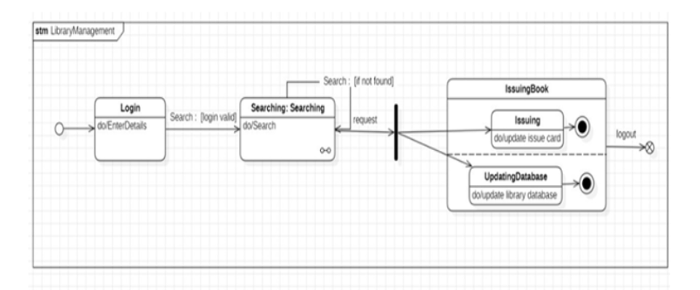
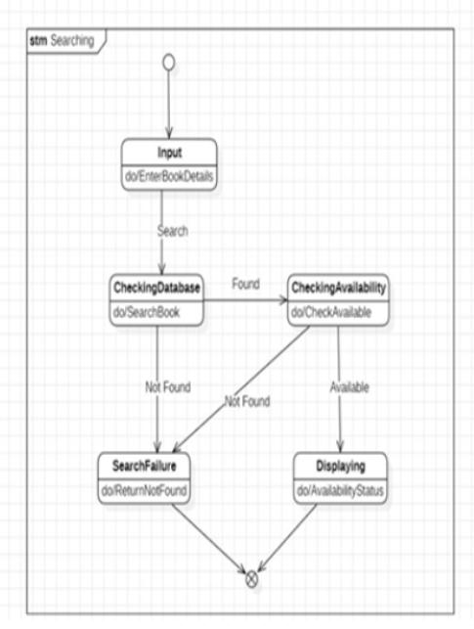
The Library Management System state diagrams illustrate how the system handles book search and issuing activities. In the advanced diagram, the workflow starts with the user logging in and then entering the Searching state, which is a composite state containing the detailed internal behavior of the search process. If the requested book is not found, the system transitions to the IssuingBook composite state, where two parallel processes—Issuing and UpdatingDatabase—run concurrently to update the user’s issue card and the library records. The simple state diagram expands the inner behavior of the composite Searching state: after receiving book input, the system checks the database, verifies availability, and either displays the availability or triggers a search failure based on guard conditions. Together, these diagrams show both the high-level flow and the internal logic of searching and issuing within the LMS.

USE CASE DIAGRAMS
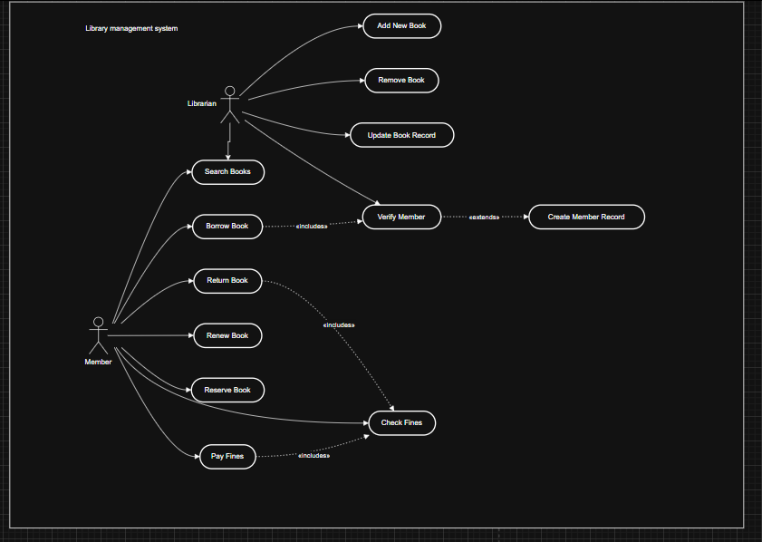
The use case diagram for the Library Management System models the interactions between two primary actors: the Librarian and the Member. The Librarian manages book-related operations, including Add New Book, Remove Book, Update Book Record, and can also Search Books and Verify Members. The Verify Member use case extends Create Member Record, meaning a new member record is created only when required. Members can perform activities such as Search Books, Borrow Book, Return Book, Renew Book, Reserve Book, and Pay Fines. Some actions depend on others—for example, Borrow Book and Pay Fines include Check Fines, as fine verification is mandatory before these actions. This diagram effectively captures both administrative and user functionalities, showing dependencies through include and extend relationships.
SEQUENCE DIAGRAM
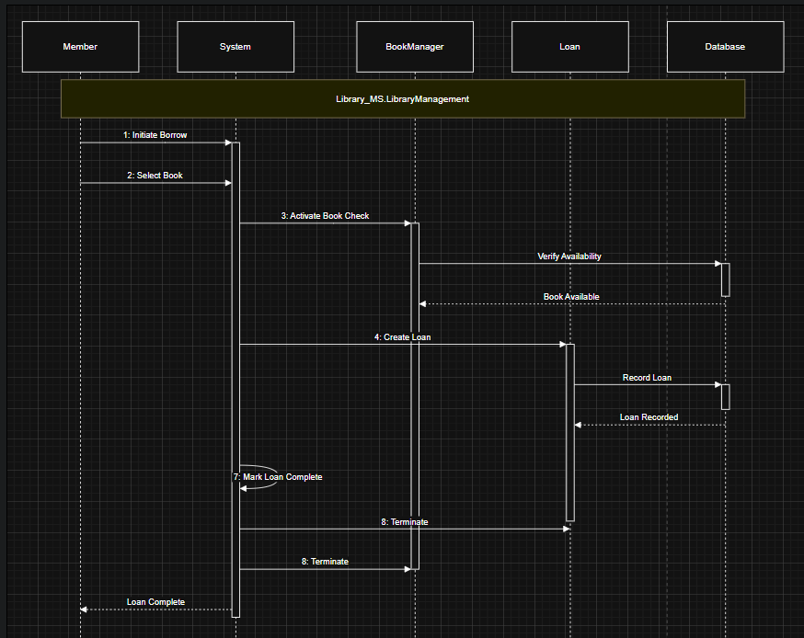
The advanced sequence diagram models the complete workflow of borrowing a book in the Library Management System. The process begins when the Member initiates a borrow request and selects a book, which the System forwards to the BookManager to activate a book-availability check. The BookManager communicates with the Database to verify whether the requested book is available. Once the book availability is confirmed, the BookManager sends the result back to the System, which then triggers the Loan object to create a new loan entry. The Loan object records the transaction by updating the Database, after which the System marks the loan as complete. Finally, termination messages are exchanged, and the Member is informed that the loan process is successfully completed. This diagram demonstrates a coordinated multi-object interaction involving transient and passive components in fulfilling the borrowing use case.

ACTIVITY DIAGRAM
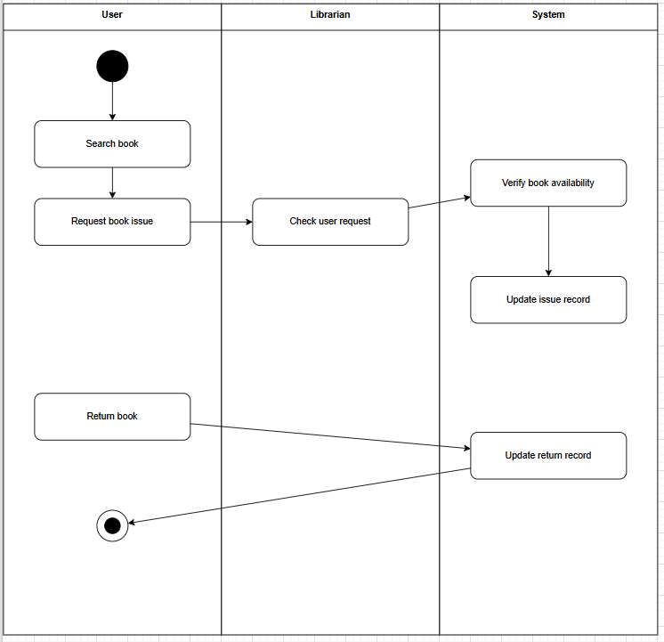
This simple activity diagram illustrates the basic workflow of issuing and returning a book in the Library Management System across three swimlanes: User, Librarian, and System. The process begins when the User searches for a book and then submits a request for book issue. The request is forwarded to the Librarian, who verifies the user’s request and passes it to the System, where the book’s availability is checked. If available, the System updates the issue record, completing the issuing process. Later, when the User returns the book, the return request is sent directly to the System, which updates the return record, and the activity flow ends. This diagram presents a simple, linear workflow showing the responsibilities of each role in issuing and returning library books.

4. STOCK MAINTENANCE SYSTEM
Problem statement
The Stock Management System aims to simplify and automate the process of managing inventory within an organization. Manual stock tracking often results in errors, delays, and data inconsistencies, affecting sales, purchasing, and overall business efficiency. This system enables accurate monitoring of stock levels, recording of incoming and outgoing items, and generating alerts for low stock. It supports administrators, stock managers, and staff members by providing real-time access to inventory records, transaction history, and reports. The system ensures improved accuracy, faster operations, and better decision-making through a centralized digital stock management workflow.

SRS
1. Introduction
1.1 Purpose
The purpose of this SRS document is to define the functional and non-functional requirements of the Stock Management System. It serves as a reference for developers, testers, and stakeholders to ensure the system meets all expectations for inventory tracking, stock updates, and reporting.
1.2 Scope
The SMS supports inventory-related operations such as adding stock, updating quantities, issuing items, generating stock alerts, and maintaining transaction reports. The system is intended for organizations that manage physical goods and need real-time accuracy. It is suitable for retail, warehouses, offices, and production units.
1.3 Overview
This document outlines system functionalities, user roles, interface requirements, performance expectations, design constraints, and implementation considerations. It also describes system interactions through diagrams such as use-case, class, activity, and sequence diagrams.

2. General Description
- The system maintains a centralized inventory database.
- Users interact with the system through role-based access (Admin, Stock Manager, Staff).
- The system supports item addition, stock updates, issuing and returning of items, and generating reports.
- SMS tracks all stock movements and maintains a complete audit trail.
- Automatic low-stock alerts help prevent shortages.
- Reports can be viewed daily, weekly, or monthly.

3. Functional Requirements
3.1 User Authentication
- System must allow secure login for Admin, Stock Manager, and Staff.
3.2 Stock Operations
- Add new stock items with details like ID, name, quantity, category.
- Update stock levels (increase or decrease quantity).
- Issue items to staff or departments.
- Process returned items.
- Delete or deactivate obsolete items.
3.3 Alerts and Notifications
- Generate automatic alerts for low stock thresholds.
- Notify Admin/Manager of expired or soon-to-expire products (if applicable).
3.4 Search and Filter
- Search items by name, category, or item ID.
- Apply filters such as “low stock,” “out of stock,” “recently updated,” etc.
3.5 Reporting
- Generate transaction reports for issued, returned, and updated items.
- View summary of available stock.
- Export reports to PDF/Excel.

4. Interface Requirements
4.1 User Interface
- Dashboard displaying stock status and alerts.
- Forms for adding, updating, issuing, and returning stock.
- Search and filter interface for quick access.
4.2 Hardware Interface
- Runs on desktop or laptop with internet access.
- Optionally connects to barcode scanner for item entry.
4.3 Software Interface
- Backend database (MySQL/PostgreSQL).
- Web or desktop application using standard frameworks.

5. Performance Requirements
- System should process stock updates within 2 seconds.
- Search operations should yield results instantly for up to 10,000 items.
- Reports should generate within 5 seconds.
- System should support 50+ concurrent users.

6. Design Constraints
- Must enforce role-based access control (RBAC).
- Must ensure transactional consistency (ACID compliance).
- Must work on commonly used browsers/systems.
- Follow proper naming conventions for stock records.

7. Non-Functional Requirements
7.1 Security
- User passwords must be encrypted.
- Only Admin can delete stock.
- All actions logged with timestamp and user ID.
7.2 Usability
- Simple layout for quick data entry.
- Clear messages for stock alerts.
7.3 Reliability
- System must operate 24/7 with minimal downtime.
- Automatic backup of the database.
7.4 Scalability
- Ability to add more items, users, and branches in the future.
7.5 Maintainability
- System should allow easy updates and debugging.

8. Preliminary Schedule & Budget
Estimated Timeline:
Phase | Duration
Requirement Analysis | 1 week
System Design | 1 week
Development | 3–4 weeks
Testing | 1 week
Deployment | 1 week
Estimated Budget:
- Developer Cost: ₹20,000 – ₹40,000
- Hardware/Software Tools: ₹5,000 – ₹10,000
- Maintenance Overheads: ₹5,000 yearly
Total Estimate: ₹30,000 – ₹55,000
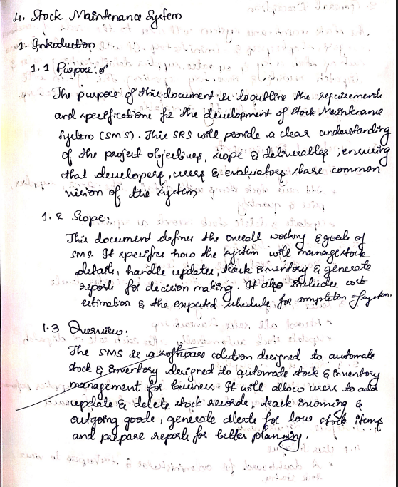

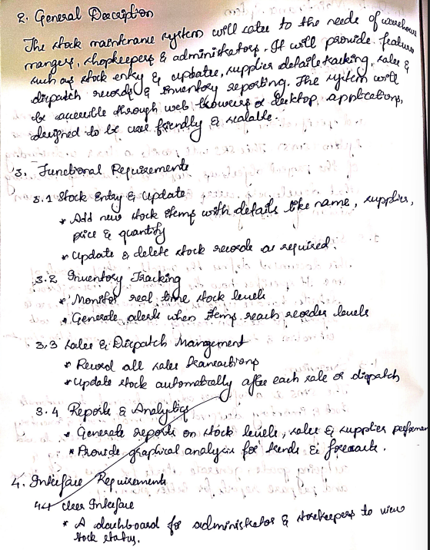
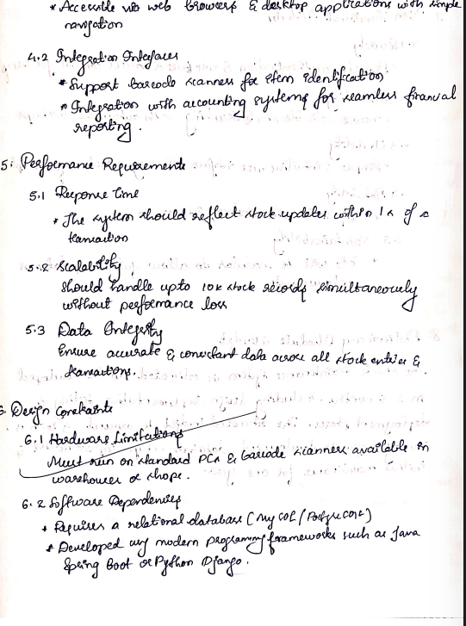
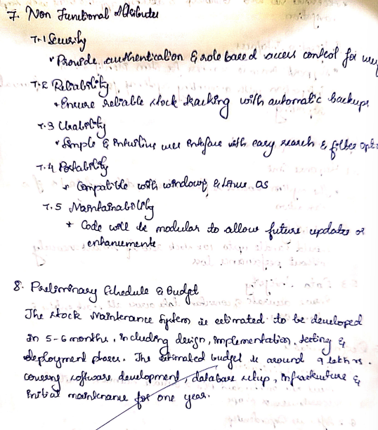

CLASS DIAGRAM
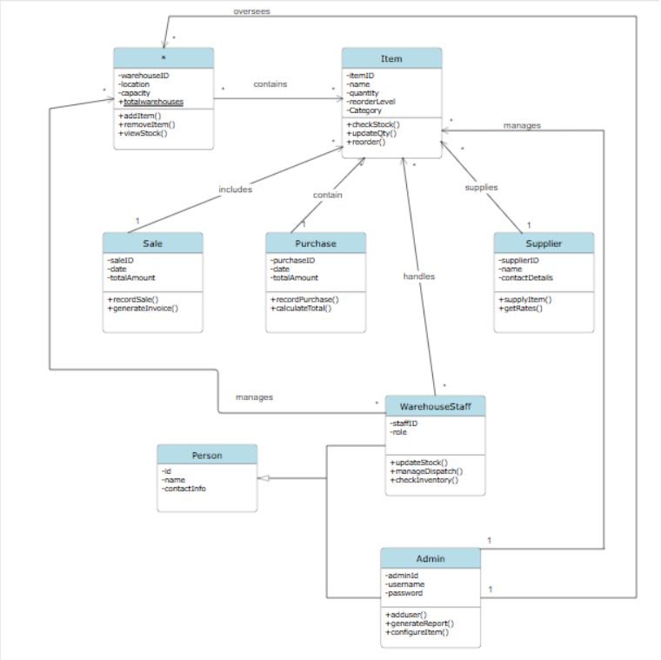
The class diagram for the Stock Management System models how stock items are managed across warehouses, suppliers, staff, and transactions. The Admin, inheriting from Person, oversees the entire system and manages WarehouseStaff, who are responsible for updating stock, managing dispatch, and checking inventory. Each Warehouse contains multiple Items, and the Item class stores essential attributes such as quantity, reorder level, and category, with operations to check stock and update quantities. Suppliers provide stock through the Supplier class, which supplies items and handles rate details. Stock movements are captured through Sale and Purchase classes, where Sale includes invoices and Purchase handles total calculations; both are associated with Items. Warehouses oversee items, staff handle item transactions, and Admin ensures system-level configuration and reporting. Overall, the diagram clearly represents inventory flow, user roles, and item handling within an organized stock management workflow.
STATE DIAGRAM
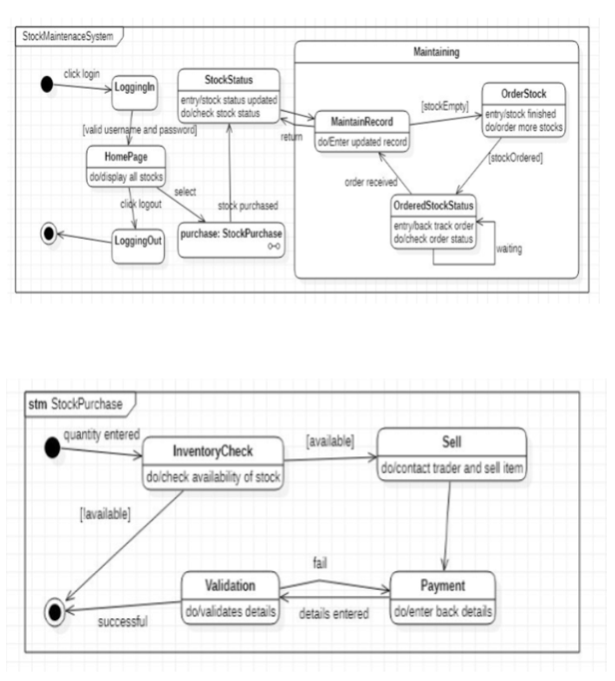
The advanced state diagram of the Stock Management System models the complete workflow from login to stock maintenance. The process begins with LoggingIn, after which the user navigates to the HomePage to view stock status. From here, the system transitions into the Maintaining composite state, which includes internal behaviors for updating stock records and handling low-stock conditions. If stock is empty, the system moves to the OrderStock state, where new stock is ordered and tracked through OrderedStockStatus until the order is received. The second diagram expands the internal logic of the StockPurchase sub-process: once quantity is entered, the system performs an InventoryCheck, and if stock is available, it proceeds to Sell the item. Payment and validation activities occur based on guard conditions, ultimately leading to a successful completion. Together, these diagrams illustrate both high-level system flow and the detailed internal behavior of purchasing and maintaining stock.

USE CASE DIAGRAM
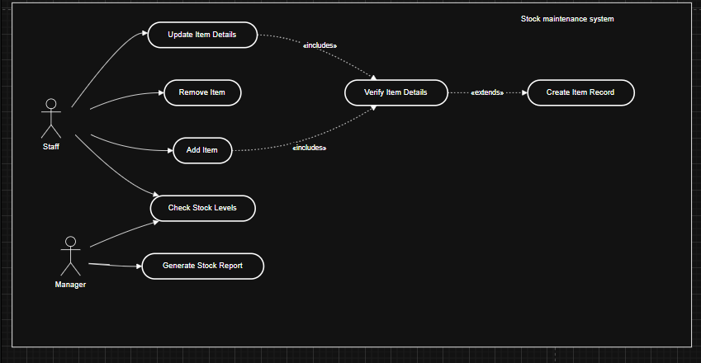
The use-case diagram models how Staff and Manager interact with the Stock Maintenance System to manage inventory data. Staff perform operational tasks such as adding items, updating item details, removing items, and checking stock levels. Before an item is added or updated, the system includes the common sub-use case Verify Item Details, ensuring accuracy and data validation. In situations where a new item does not exist, the verification process extends to Create Item Record, which is triggered only when necessary. Meanwhile, the Manager focuses on higher-level monitoring and uses the system to generate stock reports, supporting decision-making. Overall, the diagram illustrates both routine inventory processes and administrative oversight using include/extend relationships to avoid redundancy and ensure consistent item validation.

SEQUENCE DIAGRAM
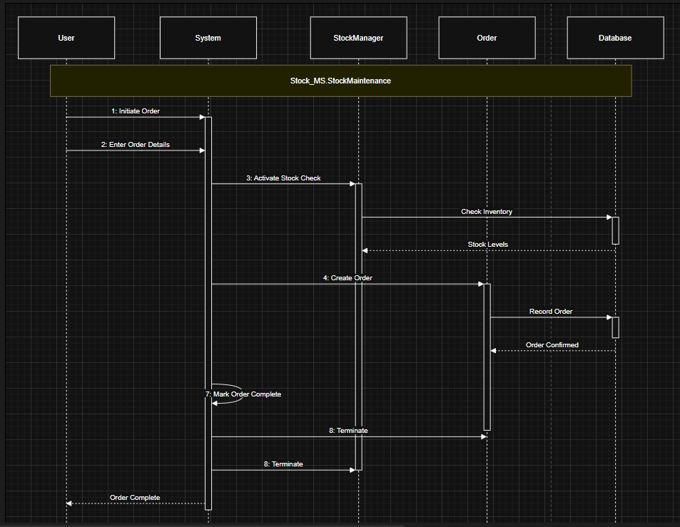
The sequence diagram models the workflow for placing a stock order in the Stock Maintenance System. The process begins when the User initiates an order, and the System prompts for order details. After receiving these details, the System triggers the StockManager to verify the availability of items. The StockManager then sends a request to the Database to check inventory levels, and the Database returns the current stock status. Based on this information, the System proceeds to create a new Order object, which is then forwarded to the Order module to record the transaction. The Order module stores the order information in the Database and sends a confirmation back. Finally, the System marks the order as complete and sends the completion status to the User, concluding the interaction.

ACTIVITY DIAGRAM
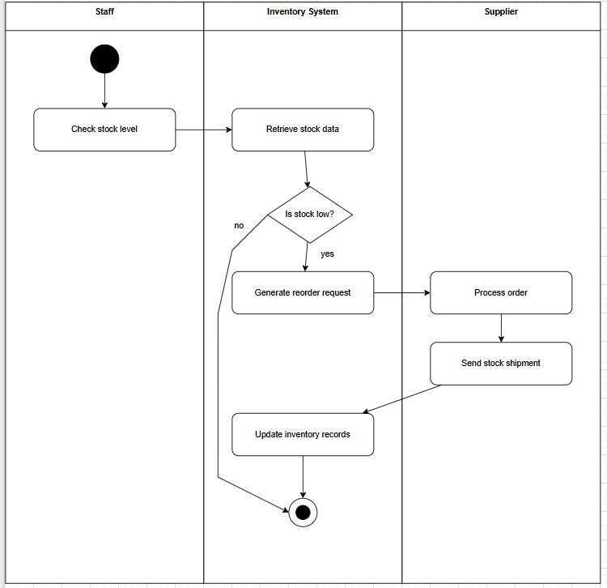
The activity diagram illustrates the automated reorder workflow in the Stock Maintenance System across three responsible entities: Staff, the Inventory System, and the Supplier. The process begins in the Staff swimlane, where the staff member initiates the operation by checking stock levels. Control then moves to the Inventory System, which retrieves the current stock data and evaluates whether the stock is low. If stock is sufficient, the system simply updates inventory records and ends the process. If the stock is low, the system generates a reorder request and sends it to the Supplier. The Supplier processes the request and ships the required stock back to the inventory system. Once received, the system updates the inventory records to reflect the replenished stock, completing the workflow.

5. PASSPORT AUTOMATION SYSTEM
Problem statement
The Passport Automation System aims to simplify and streamline the process of applying for, verifying, and issuing passports. The system replaces traditional manual processes with an online platform where applicants can submit applications, upload documents, schedule appointments, and track status updates. It ensures secure verification by officers, proper document authentication, and smooth communication with backend servers. The system reduces processing time, minimizes errors, and enhances transparency for both applicants and passport authorities.

SRS
1. Introduction
1.1 Purpose
The purpose of this SRS is to define the functional and non-functional requirements of the Passport Automation System (PAS). It describes the services provided, the interactions between users and officials, and the process of passport application, verification, and issuance.
1.2 Scope
The system allows applicants to apply for passports online, upload required documents, make payments, schedule appointments, and track application status. Passport officers can verify documents, capture biometric details, process applications, and issue passports. The system aims to improve efficiency, reduce paperwork, and ensure secure processing.
1.3 Overview
This document specifies the system architecture, functional modules, user interactions, verification workflow, and constraints. It also includes performance needs, interface requirements, and a tentative timeline.

2. General Description
- The system supports two primary actors: Applicant, Passport Officer, and Verifier.
- Applicants can register, fill forms, upload documents, and check application status.
- Officers verify documents, schedule biometrics, process the final approval, and issue passports.
- Verifiers authenticate uploaded documents.
- System provides secure login, encrypted data storage, automated notifications, and payment handling.

3. Functional Requirements
- User Registration & Login
  - FR1: Applicant shall register and log in securely.
  - FR2: System shall validate login credentials.
- Application Submission
  - FR3: Applicant shall fill the passport application form.
  - FR4: Applicant shall upload required documents (ID, address proof, DOB proof).
  - FR5: Applicant shall schedule an appointment.
- Document Verification
  - FR6: Verifier shall review uploaded documents.
  - FR7: System shall update document-verification status.
- Biometric & Interview
  - FR8: Officer shall capture biometrics (photo, fingerprints).
  - FR9: Officer shall verify identity.
- Application Processing
  - FR10: Officer shall review all submitted/verified data.
  - FR11: Officer shall accept or reject application.
- Passport Issuance
  - FR12: System shall generate passport record after approval.
  - FR13: Applicant shall be notified via SMS/email.
- Status Tracking
  - FR14: Applicant shall check real-time application status.

4. Interface Requirements
4.1 User Interface
- Simple form-filling interface for applicants
- Dashboard for officers and verifiers
- Status tracking screen
- Document-upload interface
- Appointment scheduling calendar
4.2 Hardware Interface
- Biometric devices (fingerprint scanner, camera)
- Secure servers for storing encrypted data
4.3 Software Interface
- Database management system
- API for payment gateway
- Authentication/authorization module

5. Performance Requirements
- System must support minimum 500 concurrent applicants.
- Document verification must reflect status within 5 seconds.
- Appointment scheduling updates must occur in real time.
- Response time for all user actions should be under 3 seconds.

6. Design Constraints
- Must follow government document security standards.
- Must use encrypted communication (HTTPS/TLS).
- Must integrate with external verification services (if required).
- Aadhaar/ID information should be handled as per legal guidelines.

7. Non-Functional Requirements
- Security: Encryption, role-based access, audit logs.
- Usability: Intuitive UI for applicants of all ages.
- Reliability: 99% system uptime.
- Maintainability: Modular architecture for easy updates.
- Availability: 24×7 accessible application portal.
- Portability: Support on mobile, tablet, and desktop.

8. Preliminary Schedule and Budget
8.1 Timeline (Approx.)
Phase | Duration
Requirements & Analysis | 1 week
Design (UML + architecture) | 1 week
Development | 3 weeks
Testing | 1 week
Deployment | 2–3 days
8.2 Estimated Budget
Total Estimated Budget: 12 lacks for developing and maintenance
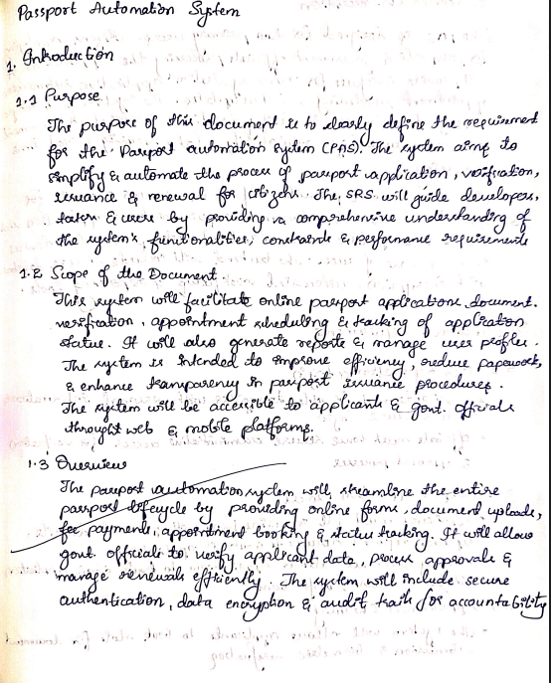
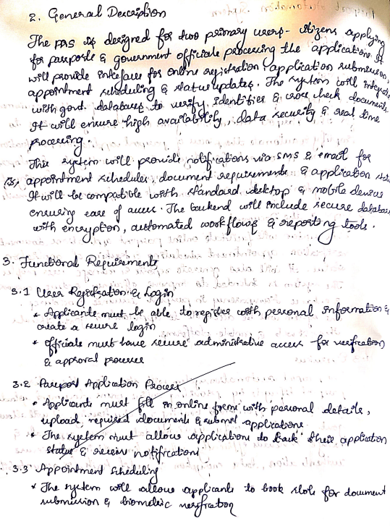
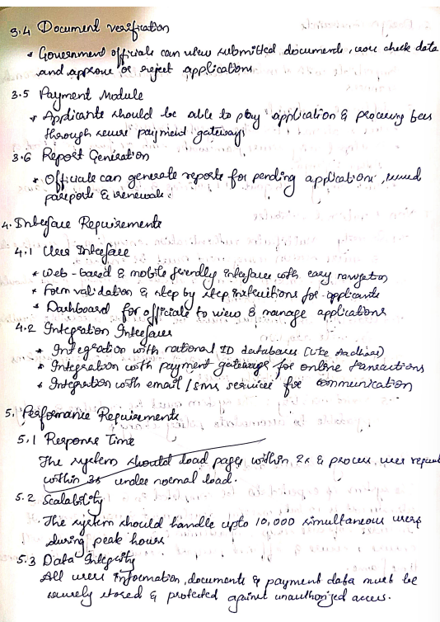

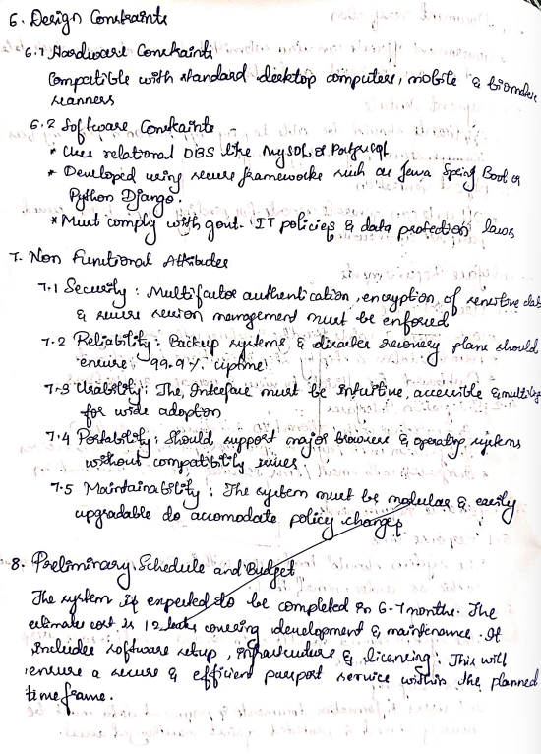

CLASS DIAGRAM
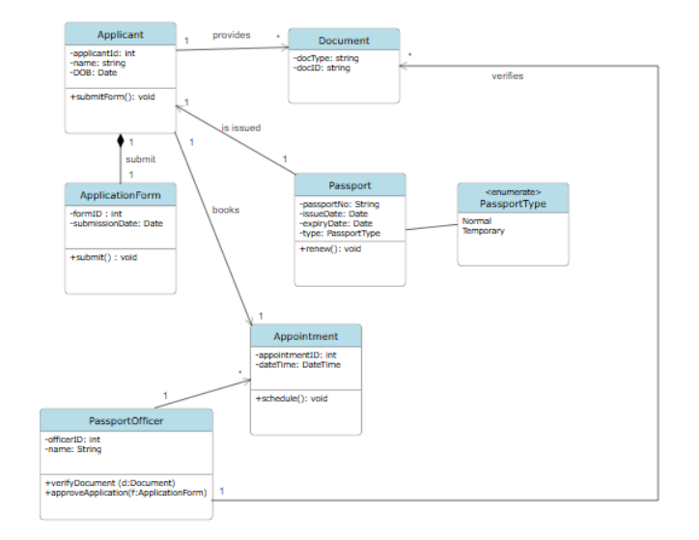
The class diagram models the key components involved in applying for and issuing a passport. The Applicant submits an ApplicationForm and provides multiple Document proofs required for verification. These documents are checked by a PassportOfficer, who also reviews and approves the application. After approval, a Passport is issued, which contains passport details such as passport number, issue/expiry dates, and type (Normal/Temporary via an enumeration). The applicant also books an Appointment, which is handled by the PassportOfficer for verification or collection. The relationships clearly show the real workflow—Applicants submit forms, provide documents, schedule appointments, officers verify details, and finally, passports are issued—capturing the complete passport automation process.

STATE DIAGRAM
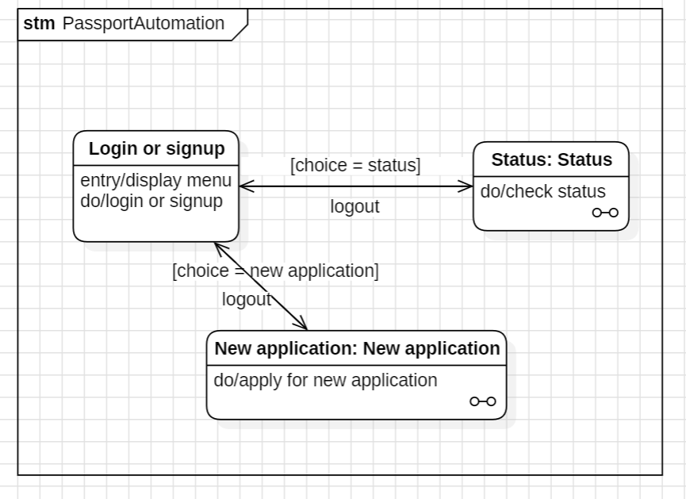
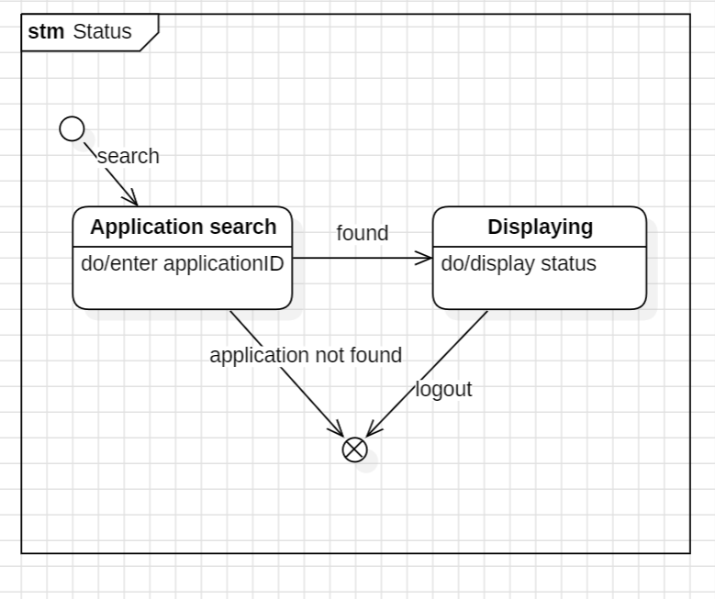
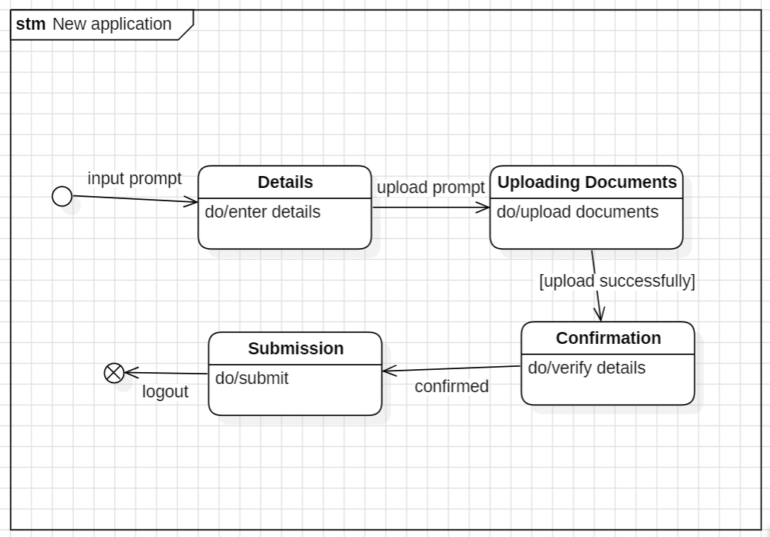
The Passport Automation state diagrams illustrate how the system handles user interactions across three key processes: login/sign-up, application status checking, and new passport applications. In the main diagram, the user begins at the Login or Signup state, where they choose to either access the system or create a new account. Based on their choice, the system transitions to either Status, where users check the current status of their application, or New Application, where they begin filling out a fresh passport request. The Status composite state expands this behavior, showing how the system processes the user’s search query: entering an application ID, checking if it exists, and either displaying the result or returning to logout if not found. The New Application composite state details the step-by-step workflow required to submit an application—entering personal details, uploading required documents, submitting the form, and finally receiving confirmation. Together, these diagrams give a complete view of how users progress through the passport system, demonstrating decision points, do-activities, system validations, and successful completion paths.

USE CASE DIAGRAM
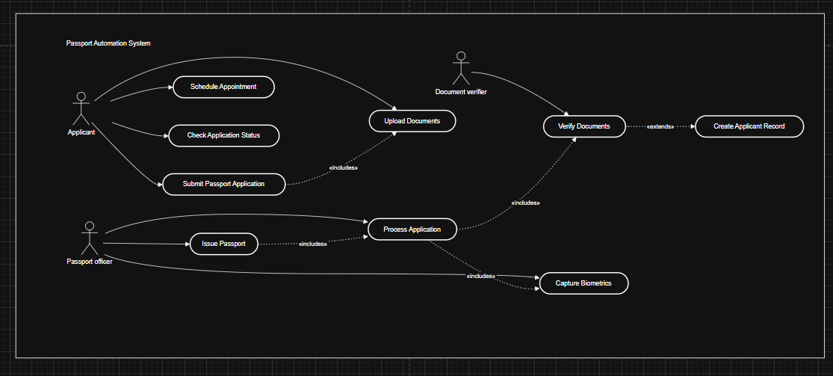
The advanced use case diagram models the interactions between different actors—Applicant, Document Verifier, and Passport Officer—and the major services offered by the Passport Automation System. The Applicant performs core actions like scheduling appointments, uploading documents, submitting applications, and checking application status. Some use cases, such as Submit Passport Application, include mandatory steps like Upload Documents, ensuring completeness.
The Document Verifier actor is responsible for validating uploaded documents, and this use case extends to the optional scenario of Create Applicant Record, which is only triggered when new applicant data must be registered. The Passport Officer handles back-office operations like Process Application, which includes verification and biometric capture, reflecting the internal workflow. The final stage, Issue Passport, depends on successful processing and is linked through an includes relationship, highlighting its dependency on thorough application processing. Overall, the diagram clearly captures workflow dependencies through include and extend relationships, reflecting a structured and efficient passport automation process.

SEQUENCE DIAGRAM
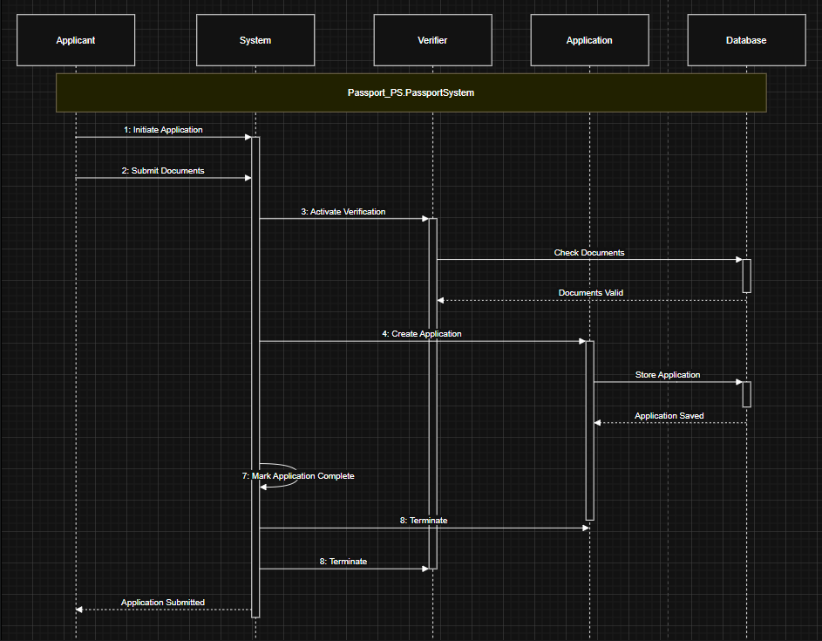
This advanced sequence diagram illustrates the complete workflow for the “Submit Passport Application” use case in the Passport Automation System, incorporating both passive and transient objects.
The sequence starts with the Applicant, who first initiates the application process and proceeds to submit their documents to the System. The System then triggers a verification step by activating the Verifier component, which checks the submitted documents. The Database acts as a passive object, storing previously available applicant and document data. After verification is complete and the documents are validated, the System proceeds to create an Application object, which is a transient object created specifically for this processing flow.
The Application object is then stored permanently in the database, marking the creation of a new application record. After successful storage, the System marks the entire operation as complete and sends the final confirmation back to the Applicant. Finally, both transient object lifelines are terminated as required.
Overall, the diagram clearly demonstrates the flow of control across actors and system components, making use of creation (<<create>>) and termination (destroy) events, and showing how temporary and permanent elements of the system interact to complete the passport application process.

ACTIVITY DIAGRAM
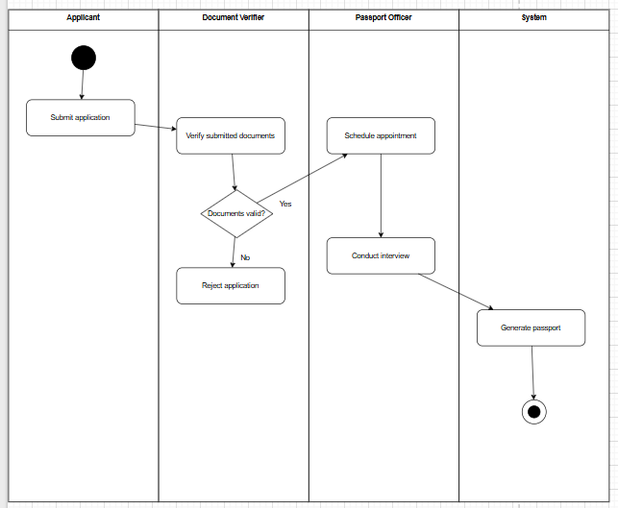
This activity diagram illustrates the complete workflow of passport processing, involving four swimlanes: Applicant, Document Verifier, Passport Officer, and the System.
The process begins when the Applicant submits an application, triggering the Document Verifier to validate the submitted documents. A decision node checks whether the documents are valid:
- If documents are NOT valid, the application is rejected immediately.
- If documents ARE valid, the process moves to the Passport Officer.
The Passport Officer then schedules an appointment and later conducts the applicant’s interview. Based on successful completion of the interview, the workflow transitions to the System, which generates the passport, marking the end of the process.
This diagram effectively shows decision flow, responsible actors, and the system's automated role in generating the final passport once manual verification and interview steps are completed.

